Patient Education- WHIPPLE OPERATION

Contents
About your operation 2
Treatment options 5
PREPARING FOR YOUR OPERATION 8
Presurgical Assessment 9
DAY BEFORE THE OPERATION 11
Information for Family and Friends for the Day of Surgery 16
After your operation 18
Commonly Asked Questions 19

About your operation

This guide will help you prepare for your liver surgery at St. Joseph’s Hospital. It is very important that you read this guide TWICE so that you understand all the aspects involved during and after your operation. You will do well if you know what to expect. We will continue to explain during each of our meeting. After all, it’s all about your health.

Dr. Sukharamwala has already explained to you the details of the operation and drew pictures of your operation and discussed what to expect. We also have discussed the risk and complications involved.

IF YOU HAVE ANY FURTHER QUESTIONS THAT COME UP WHILE READING THIS EDUCATION GUIDE, PLEASE WRITE IT DOWN IN “NOTES “SECTION AT THE END OF THIS MANUAL. DR. SUKHARAMWALA WILL BE GLAD TO DISCUSS AT YOUR NEXT MEETING OR BEFORE THE OPERATION.

About the Pancreas

Pancreas is the organ located in front of your spine and behind the stomach. The main function of the pancreas is to make hormone.

Endocrine hormones: These includes insulin and Glucagon. These hormones help with regulating your blood glucose. Removing only a part of the pancreas does not make you diabetic in most cases.

Exocrine Hormones: These includes digestive enzymes which help digesting proteins, carbohydrates and fat. These enzymes will help digestion and absorption of the food you eat.

Pancreatic Tumors

As the name implies, the pancreatic tumor arises from the pancreas. Pancreas is an organ that lies in the back of the abdomen behind the stomach. Normally the pancreas functions to help digestion and secretes hormones that control the blood sugar.

There are two types of cells from which the pancreatic tumor can arise:

- Hormone-producing cells (Pancreatic neuroendocrine tumor PNET).
- Pancreatic ductal cells (Pancreatic adenocarcinoma). The majority of pancreatic cancers are adenocarcinomas.

Pancreatic Neuroendocrine tumors have good prognosis if resected.

Pancreatic adenocarcinoma often has a poor prognosis, with surgery the only chance of cure in cases when there is no detectable cancer spread. Pancreatic cancer typically spreads rapidly and is often detected at late stages, which is a major reason why it's a leading cause of cancer death.

Pancreatic cancer typically causes symptoms like

- Upper abdominal pain that may radiate to your back
- Yellowing of your skin and the whites of your eyes (jaundice)
- Loss of appetite
- Weight loss
- Depression

Diagnosing pancreatic cancer
Some of the common test done for pancreatic cancer are abdominal ultrasound, computerized tomography (CT) scan and magnetic resonance imaging (MRI).
Many times we will order further evaluation of the pancreatic tumor using Endoscopic Ultrasound with Fine Needle Aspiration. An endoscopic ultrasound (EUS) uses an ultrasound device to make images of your pancreas from inside your abdomen. The ultrasound device is passed through a thin, flexible tube (endoscope) down your esophagus and into your stomach in order to obtain the images. This procedure is done by the Gastroenterologist under anesthesia. Through this test, pancreatic tumor tissue can be evaluated for accurate diagnosis of the type of pancreatic tumor.

If you have jaundice, Gastroenterologist may also have to do Endoscopic retrograde cholangiopancreatography (ERCP), a test which uses a dye to highlight the bile ducts in your pancreas. During ERCP, an endoscope is passed down your throat, through your stomach and into the upper part of your small intestine. A dye is then injected into the pancreatic and bile ducts through a small hollow tube (catheter) that's passed through the endoscope. Finally, X-rays are taken of the ducts. A stent will be placed to relieve the obstruction of the bile duct.
- A tissue or cell sample (biopsy) can be collected during ERCP.
- A stent can be placed to bypass the blockage to help with the obstruction jaundice.

Stages of pancreatic cancer
Using available information, pancreatic cancer can be staged as follow.
- Stage I. Cancer is confined to the pancreas.
- Stage II. Cancer has spread beyond the pancreas to nearby tissues and organs and may have spread to the lymph nodes.
- Stage III. Cancer has spread beyond the pancreas to the major blood vessels around the pancreas and may have spread to the lymph nodes.
- Stage IV. Cancer has spread to distant sites beyond the pancreas, such as the liver, lungs and the lining that surrounds your abdominal organs (peritoneum).

Treatment options

For tumors located in the head of pancreas Whipple operation is indicated
The only curative option for pancreatic cancer is surgical resection. If the tumor is identified in stage I, prognosis is better. The following image will better help understand the Whipple operation. Better survival is seen if your tumor is Stage I. If your tumor is confined to pancreas, we will recommend Whipple procedure or Pancreaticoduodenectomy
ANATOMY OF THE FOREGUT
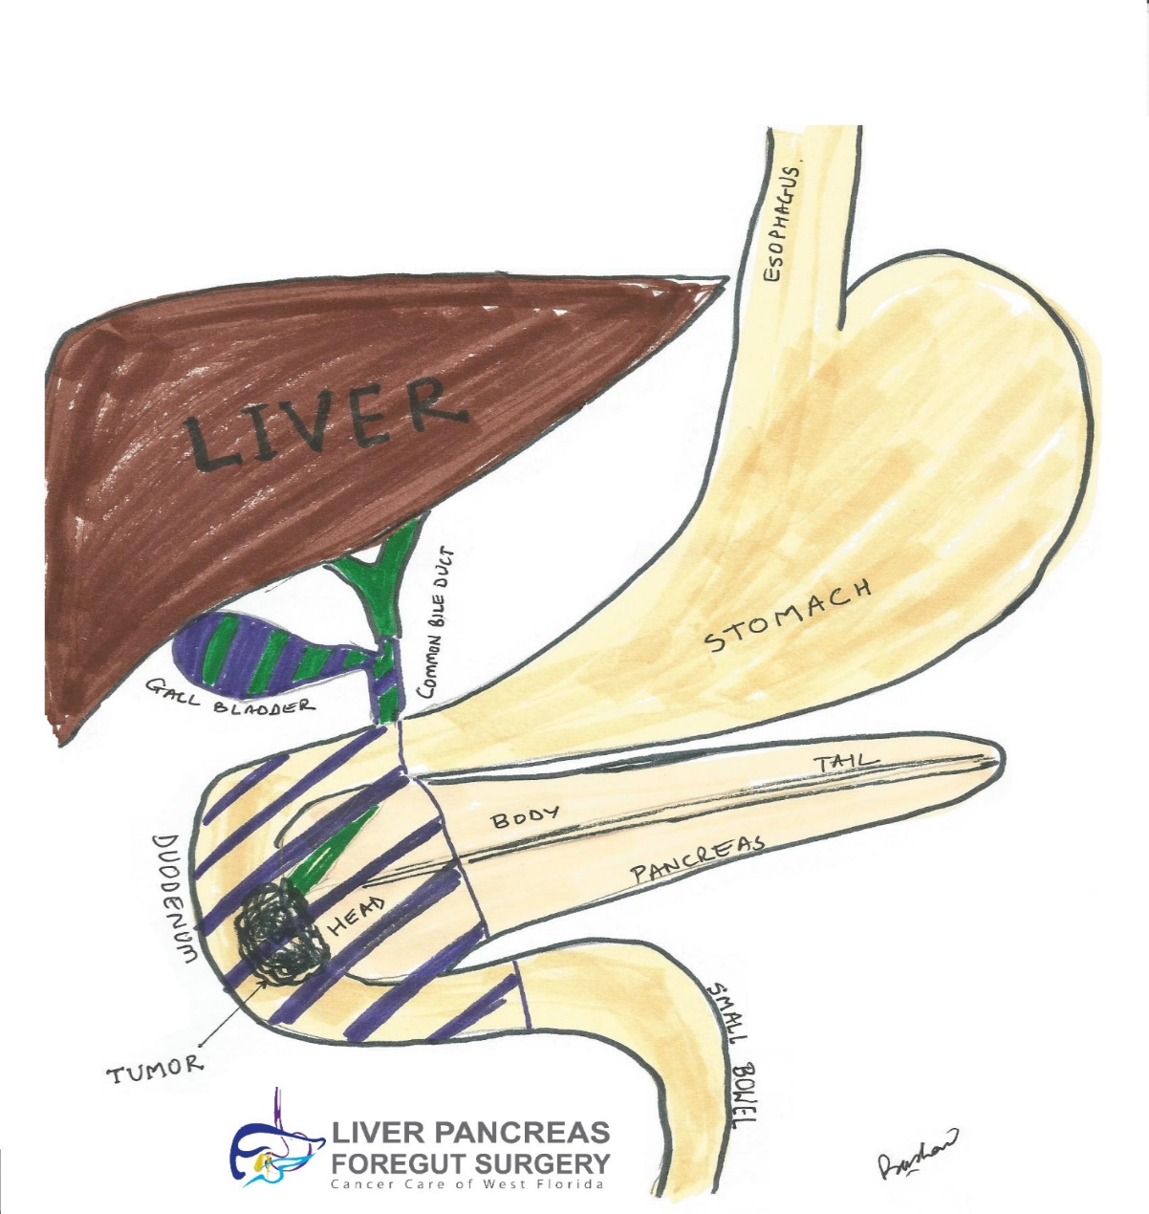
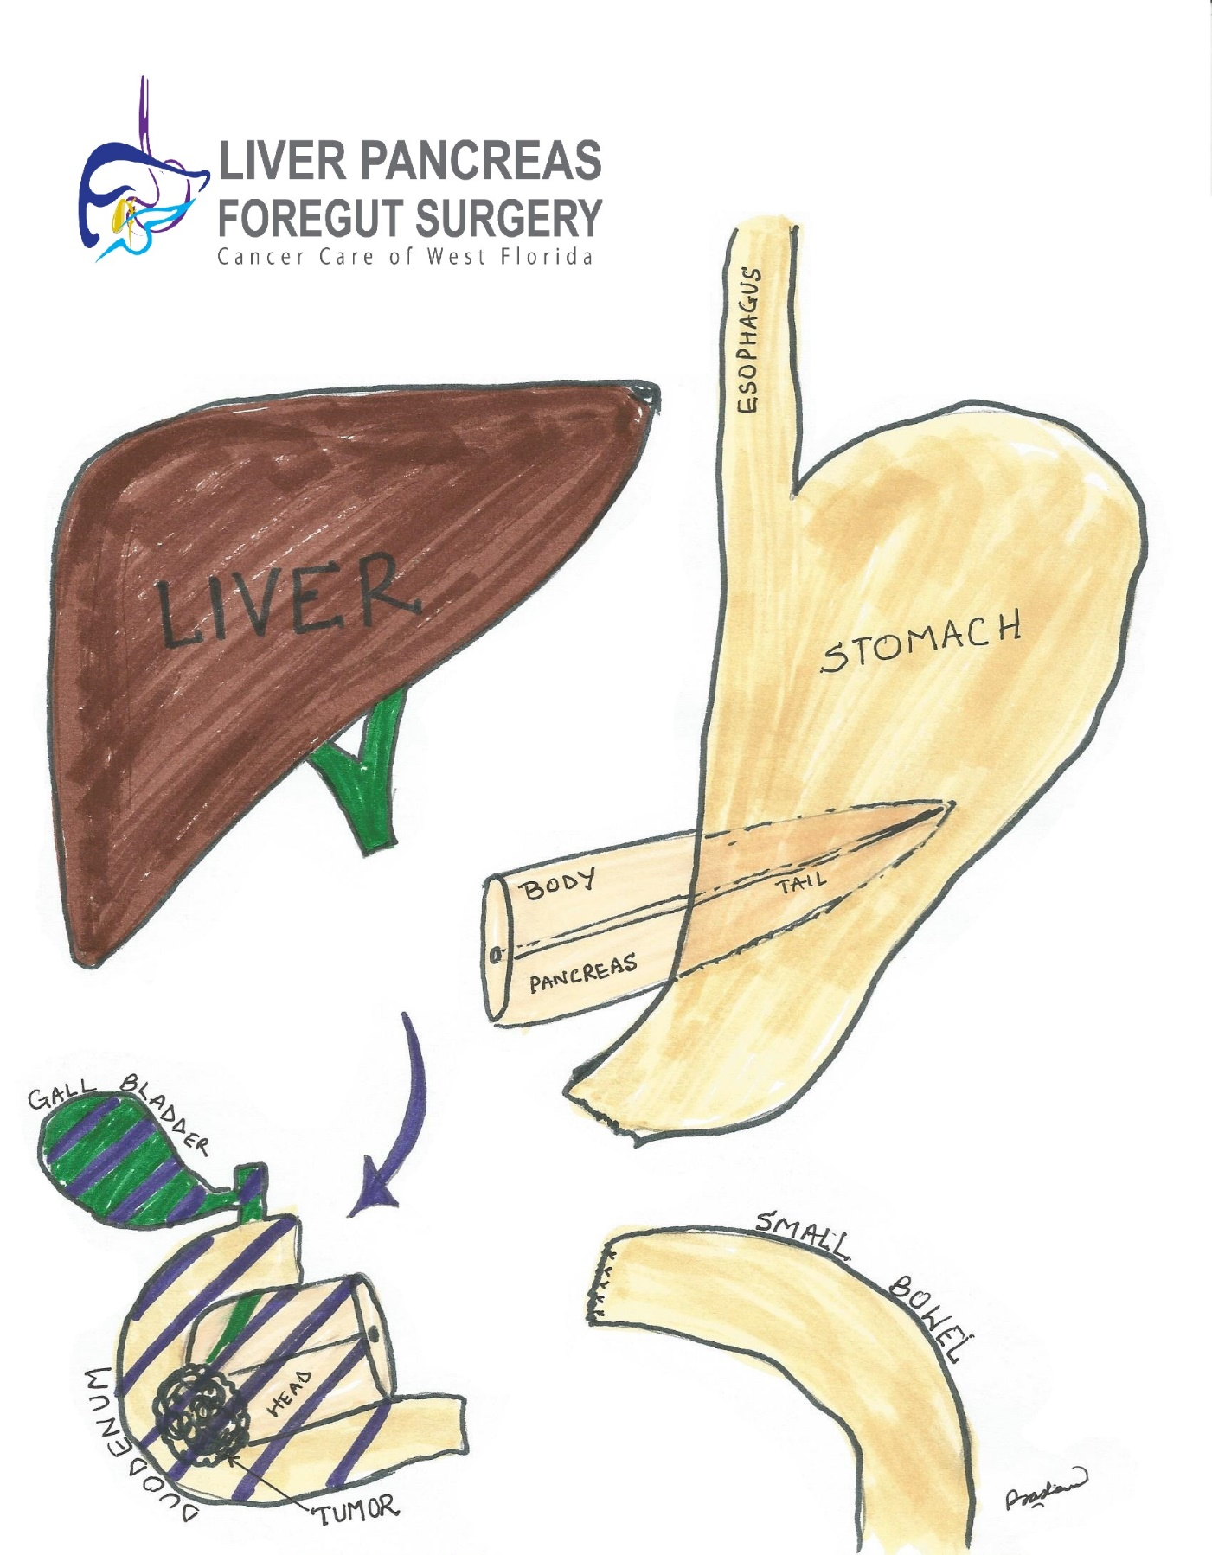

REMOVAL OF THE TUMOR

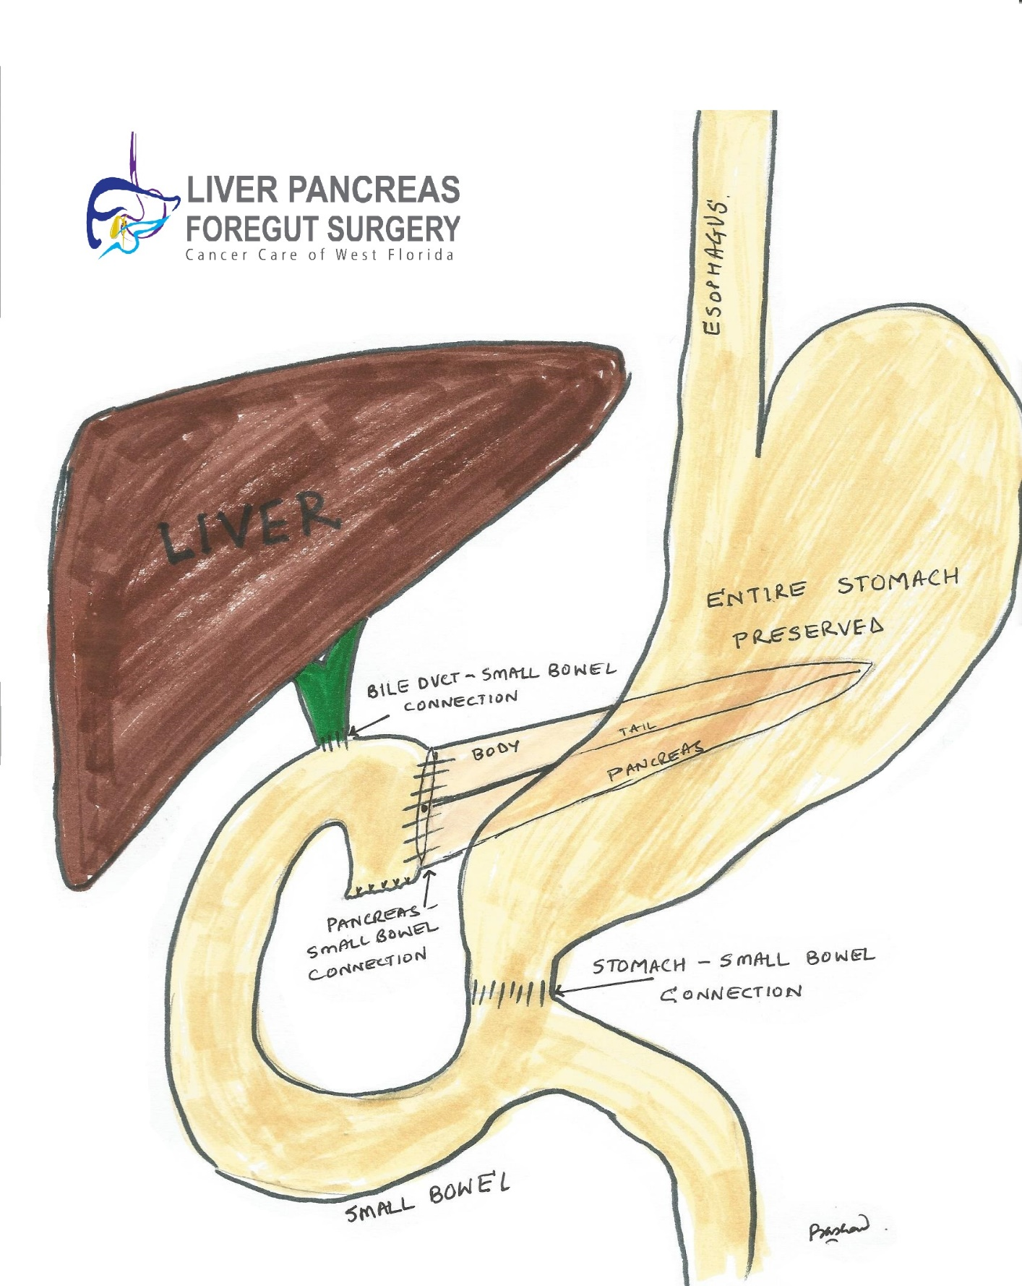

RECONSTRUCTION OF INTESTINES

PREPARING FOR YOUR OPERATION

If you drink Alcohol:

Dr. Sukharamwala will like you to stop drinking alcohol 2 weeks before your operation. This is important due to the following reasons

• Suddenly stopping alcohol leads to a condition called Delirium tremens. This may cause seizures, delirium, respiratory failure and death. If we know you are risk for these complications, we can prescribe medication to help prevent them.

• Alcohol consumption also leads to complications after your operation. These include bleeding, infections, heart problems, pneumonia and a longer hospital stay.

Here are things you can do to prevent problems before your surgery:

• Be honest with our team about how much alcohol you drink.

• Try to stop drinking alcohol once your surgery is planned. If you develop sweating, anxiety, Palpitation (Racing of heart), tremors and headache, please contact your primary care physician right away.

If you Smoke:

Dr. Sukharamwala will like you to stop drinking alcohol 2 weeks before your operation. This is important due to the following reasons

- Smoking immediate before your operation will lead to increased complications like pneumonia, wound infections, abscess, heart attacks, blood clots formation and stroke.
- Toxins in the smoke causes increased mucus production and coughing. Increased coughing after your operation can cause wound problems including incision break down and hernia formations.

If you have Sleep Apnea

Sleep apnea is a common breathing disorder that is seen particularly in obese patients. Sleep apnea can cause serious problems when you have surgery. Please tell us if you have sleep apnea or if you think you might have it. If you use a breathing machine (CPAP) for sleep apnea, bring it with you the day of your surgery.

Presurgical Assessment

Before your surgery, you will have an appointment for presurgical testing. This appointment I important to get your ready for the operation. The date, time, and location of your appointment will be given to you before you leave our office.

You can eat and take your usual medications the day of your PST appointment. During your appointment, you will meet with our presurgical team comprised of Nurse, nurse practitioner or Doctor who works closely with anesthesiology. He or she will review your medical and surgical history with you. You will have tests, including an electrocardiogram (EKG) to check your heart rhythm, a chest x-ray, blood tests, and any other tests necessary to plan your care.

PLEASE BRING THE FOLLOWING TO THE PRESURGICAL TESTING

- A list of all the medications you are taking.
- Results of any heart test such as a cardiac stress test, echocardiogram, or carotid Doppler study
- Cardiac clearance obtained from the heart doctor.
- The name(s) and telephone number(s) of your doctor(s)

Health Care Proxy
If you haven’t already completed a Health Care Proxy Form, we recommend you complete one now. A health care proxy is a legal document that identifies the person who will speak for you if you are unable to communicate for yourself. This person is known as your health care agent. If you are interested in completing a Health Care Proxy Form, talk with your nurse. If you have a health care Proxy document, please bring it to Presurgical Testing.
Exercise
Try to do aerobic exercise every day, such as walking at least 1 mile, swimming, or biking. This will help to get your body into its best conditions for your surgery and make your recovery faster and easier. Losing a couple of pounds of weight will go long ways as it makes the operation easier.

Medications
It is ok to continue to take Aspirin before your operation. If you take Plavix or other blood thinners, please see your heart doctor how we can bridge on an alternate medication before your surgery.

DAY BEFORE THE OPERATION

Purchase Hibiclens® Skin Cleanser

Hibiclens® is a skin cleanser that kills germs for 6 hours after using it. Take shower using Hibiclens® evening before and morning on the day of the operation. Hibiclens is available at your local pharmacy without a prescription. Open the Hibiclens® bottle and pour some solution into your hand or a scrub. Rub it gently over your body from your neck to your waist and rinse. Do not use any other soap. Do not let the solution get into your eyes, ears, mouth, or genital area. Dry yourself off with a clean towel after your shower.

Diet

On the day before your surgery, please drink clear liquid diet.
Examples
- Clear broth or bouillon
- Clear consommé
- Packaged vegetable, chicken, or beef broth
- Gelatin, such as Jell-O®
- Hard candies, such as Lifesavers®
- Clear fruit juices, such as cranberry, grape, apple ( Avoid red juices)
- Soda, such as 7-Up®, Sprite®, ginger ale, seltzer, Gatorade
- Black coffee
- Tea

Avoid liquid which have RED COLORING ADDED TO IT.

Bowel preparation

Purchase a bottle of Magnesium Citrate. This is available at your local pharmacy without a prescription.

• At 3:00 pm on the day before your surgery, drink the magnesium citrate bottle. This will help you purge and clean your bowels. This makes the operation easier.

Timing of the operation.

A clerk from the OPERATING ROOM will call you after 2:00 pm the day before your surgery. You will be told what time you should arrive at the hospital for your surgery. If you are scheduled for surgery on a Monday, you will be called on the Friday before. If you do not receive a call by 7:00 pm, please call (813) 879-5010

Use this area to write in the information

Date :
Time :

Morning of Your Surgery

Shower with Hibiclens
Take shower using Hibiclens® evening before and morning on the day of the operation. Hibiclens is available at your local pharmacy without a prescription. Open the Hibiclens® bottle and pour some solution into your hand or a scrub. Rub it gently over your body from your neck to your waist and rinse. Do not use any other soap. Do not let the solution get into your eyes, ears, mouth, or genital area. Dry yourself off with a clean towel after your shower.

Take Your Medications

You are allowed to take any heart or diabetes medication as instruction by your Doctor.
Do not eat or drink anything the morning of your surgery. This includes water, hard candy, and gum. Take any medication as instructed with a small sip of water.

Important Instructions

- Wear something comfortable and loose-fitting. Avoid jeans or tight shirt.
• Do not wear any make up, lotions, earing or perfumes
- Do not wear Contact lenses. Wear your glasses instead.
• Remove all jewelry, including body piercings. A metal object on your body will cause burns from arching when a electrocautery is used during the operation.
- Leave credit cards, jewelry, or your checkbook at home.

You may Bring

- Bring your BiPAP Machine if you have sleep apnea. You will need it after your operation.
- Bring your Health Care Proxy Form, if you have completed one.
- Your cell phone and charger.
- This guide. Your healthcare team will use this guide to teach you how to care for yourself after your surgery.

Parking when you Arrive

We recommend you drive with your family member. At your discharge you will not be allowed to drive as you will be given Narcotic pain medications.
Free Valet parking is available at the main Hospital entrance. Walk towards the main elevators and take the elevators to the SECOND Floor. Right in front of the elevators is the Surgery Check – in. You will report to the personnel at the Check – in who will assist you from there.

In the Operating Room

Once your nurse has seen you, 1 or 2 visitors can keep you company as you wait for your surgery to begin. When it is time for your surgery, your visitor(s) will be shown to the waiting area. Your visitors should read Information for Family and Friends for the Day of Surgery, located in this section.

You will walk into the operating room or you can be taken in on a stretcher. Compression boots will be placed on your lower legs. These gently inflate and deflate to help circulation in your legs.

Your anesthesiologist will place an intravenous (IV) line into a vein, usually in your arm or hand. The IV line will be used to give you fluids and anesthesia (medication to make you sleep) during your surgery.

Once you are fully asleep, a breathing tube will be placed through your mouth and into your windpipe to help you breathe. You will also have a urinary catheter placed to drain urine from your bladder.

Once your surgery is finished, your incision will be closed with staples or with stitches that will absorb as you are healing. Steri-StripsTM (thin pieces of tape) will be placed directly on your incision and covered with a bandage. Your breathing tube is usually taken out while you are still in the operating room.

Information for Family and Friends for the Day of Surgery

Before the Surgery

After arriving at the hospital, the patient will identify the contact person who will be meeting with the surgeon after the surgery. This is also the same person who will get updates from the nurse during the surgery. If the contact person is not going to be present all the time during or after the operation, please provide the contact number for the health care proxy. Dr. Sukharamwala will contact the family member to update about your condition.

When the operating room (OR) is ready, the surgical team will take the patient there. They will prepare the patient for surgery, which can take 15 to 90 minutes. Then, the surgery will begin.

Please remember the following:

After the patient is taken to the OR, please wait in the waiting area.

Free Wi-Fi is available in the waiting area.

Please do not visit if you have any cold or flu symptoms (fever, sneezing, sniffles, or a cough).

If the patient brought any valuables, such as a cell phone, jewelry etc., please keep them safe for him or her during surgery.

Sometimes, surgeries are delayed. We make every effort to tell you when this happens.

Food and drinks are available on the 1s t floor in the cafeteria. You can also bring your own food and eat it in the cafeteria.

Chapel located on the 1s t floor. It is open at all times for meditation and prayer.

Surgery updates

A nurse liaison will keep you updated on the progress of surgery. He or she will:

Give you information about the patient.

Prepare you for your meeting with the surgeon.

Prepare you for visiting the patient in the Post Anesthesia Care Unit (PACU).

After the Surgery

Dr. Sukharamwala will meet you (the family member) in the consultation room and update you on the status of the operation and condition of your loved ones.

After surgery, the patient will be taken to the PACU. Due to the effects of the anesthesia, it can take up to 60 minutes before the patient is ready to have visitors. When the patient is able to have visitors, a staff member will take you to the PACU.

Once the patient is being transferred to the private room or ICU, you will be escorted together with the patient.

After your operation

When you wake up after your surgery, you will be in the Post Anesthesia Care Unit (PACU).
You will have venous catheter, nasogastric tubes, Foley catheter and wires monitoring you in the PACU.

A nurse will be monitoring your body temperature, pulse, blood pressure, and oxygen levels.

You may have a pain pump called a patient-controlled analgesia (PCA) device. PCA device allows you to administer pain medication every 10 min interval to help with better pain control. The device is programmed in a way to avoid any overdose.

Depending on your condition, you may stay in the ICU overnight. After your recover for a day in the ICU, you will be taken to your hospital room. Soon after you arrive in your room, you will be helped out of bed and into a chair. Your nurse will tell you how to recover from your surgery. Below are examples of ways you can help yourself recover safely.

• Walk, Walk and Walk. We will give you medication to relieve pain during walking. Walking helps prevent any blood clot. Also it may stimulate bowel function to resume early.

• You will not be allowed to eat for the first day or two. Then, you will be given clear liquids. After that, your diet will progress to a regular diet as tolerated your bowel function resume. Once you are tolerating your diet well and no complications are seen, we will start the discharge planning.

- You will meet the case manager early on during your hospitalization. Case managers work close with social workers who will assess your social needs at the time of your discharge. Based on your physical condition and recovery you may be advised to be discharged to rehabilitation place or a skilled nursing facility.

• Use your incentive spirometer. This will help your lungs expand, which prevents pneumonia.

Commonly Asked Questions

Will I have pain after my surgery?

Yes, you will have pain after your surgery, especially in the first few days. We will order IV pain medication to help with pain control. This will be transition to oral pain medication. Pain medications blunt the edge of the pain.

Why is it important to walk?

Walking will help prevent blood clots in your legs. It also decreases your risk of having other complications such as pneumonia.

Will I be able to eat?

You will not be allowed to eat for the first day or two. Then, you will be given clear liquids. After that, your diet will progress to a regular diet as tolerated your bowel function resume. Once you are tolerating your diet well and no complications are seen, we will start the discharge planning

How long will I be in the hospital?

Most patients are in the hospital for 5 to 7 days after having a Whipple operation. If any complication is noted, your hospital stay may be prolonged often times up to 2 weeks.

Will I have pain when I am home?

As your incision heals, you will have less pain and need less pain medication. We generally recommend you transition over to non-narcotic pain medications. A mild pain reliever such as acetaminophen (Tylenol) or ibuprofen (Advil) will relieve aches and discomfort. However, large quantities of acetaminophen may be harmful to your liver.

Can I shower?

Yes, we encourage you to take shower by third day post Op. Your nurse will help you to take shower during your hospital stay. We recommend you avoid bath tub for a full 2 weeks after your operation.

Is it normal not to feel hungry after surgery?

Generally your appetite is reduced after your operation. As you heal, we recommend try to eat protein rich diet to help with healing. Often times with general anesthesia, the sense of smell is affected. This leads to reduced appetite. We recommend you go out daily in fresh air and sun shine. This helps restore your sense of smell and bring back your appetite.

How can I prevent constipation?

Due to the narcotics pain medications given during and after the operation, you may develop constipation, however as you recover, your bowel movements will normalize. We also recommend you take over the counter stool softeners if you have constipation.

To avoid constipation, take a stool softener such as docusate sodium (Colace®) 3 times a day and 2 tablets of Senna (a laxative) at bedtime. Continue taking the stool softener and laxative until you are no longer taking pain medication. Drink plenty of liquids. If you feel bloated avoid foods that can cause gas, such as beans, broccoli, onions, cabbage, and cauliflower.

Can I drink alcohol after surgery?

Do not drink alcohol until you check with your doctor

How do I care for my incision?

By the time you are ready to leave the hospital, your surgical incision will have begun to heal.
If any liquid is draining from your incision, call your doctor’s office and speak with the nurse about any drainage from your incision.

If you go home with Steri-Strips on your incision, they will loosen and fall off by themselves. If they haven’t fallen off within 10 days, you may remove them.

If you go home with glue over your sutures (stitches), it will also loosen and peel off, similarly to the Steri-Strips.

Can I resume my activities?

Your body is an excellent guide for telling you when you have done too much. When you increase your activity, monitor your body’s reaction. You may find that you have more energy in the morning or the afternoon.

It is important for you to resume your activities after surgery. Spread them out over the course of the day. You can do light household tasks. Try washing dishes, preparing light meals, and other activities as you are able.

When is it safe for me to drive?

You may resume driving 3 weeks after surgery as long as you are not taking pain medication that may make you drowsy.

When can I return to work?

The time it takes to return to work depends on the type of work you do, the type of surgery you had, and how fast your body heals. . Ask your doctor when you can resume work in general.

What exercises can I do?

Exercise will help you gain strength and feel better. Walking and stair climbing are excellent forms of exercise. Gradually increase the distance you walk. Climb stairs slowly, resting or stopping as needed. Ask your doctor or nurse before starting more strenuous exercises.

When can I lift heavy objects?

Check with your doctor before you do any heavy lifting. Normally, you should not lift anything heavier than 5 pounds for at least 6 weeks. Ask your doctor when you can resume heavy lifting.

When is my first appointment after my surgery?

Your first appointment after surgery will be in 1 to 2 weeks after you leave the hospital.
During this appointment, your doctor will discuss the pathology results with you in detail.

Call your doctor if you have:

• A temperature of 101° F (38.3° C) or higher

• Pain that does not get better with your medications

• Redness, swelling, or drainage from your incision that is foul smelling or pus-like

• No bowel movement for 3 days or longer

• Nausea or vomiting

• Jaundice (yellow skin or eyes)

• Diarrhea

• Constipation that does not get better in 2 to 3 days

• Any new symptom or physical change

• Any questions or concerns

If you have any questions or concerns call us anytime at (813) 879-5010. If you speak with the Answering Service, ask to speak to the doctor on call.

NOTES

………………………………………………………………………………………………………………………………………………………………………………………………………………………………………………………………………………………………………………………………………………………………………………………………………………………………………………………………………………………………………………………………………………………………………………………………………………………………………………………………………………………………………………………………………………………………………………………………………………………………………………………………………………………………………….

